QUESTION 24 – FILL-MASK VOCABULARY TRAINER
Assessment Record
Student Name | M. Someswar Reddy
Register Number | 192472081
Aim
To develop a Fill-Mask Vocabulary Trainer using a Hugging Face masked-language model and generate the top-5 predictions for masked words in five sentences.
Objective
To use the google-bert/bert-base-uncased model to predict missing words from sentence context, including a proper-noun example.
Requirements
• Python 3.10 or above
• Transformers
• PyTorch
• Hugging Face
• google-bert/bert-base-uncased
Model and Parameters
Model | google-bert/bert-base-uncased
Task | Fill-Mask Language Modeling
Top-K | 5
Mask Token | [MASK]
Procedure
1. Install the required libraries.
2. Import the Hugging Face fill-mask pipeline.
3. Load the BERT fill-mask model.
4. Prepare five sentences containing [MASK].
5. Generate the top-5 predictions.
6. Display the predicted words and scores.
7. Check the proper-noun test case.
8. Record the actual output and result.
Algorithm
Step 1: Start.
Step 2: Load the fill-mask model.
Step 3: Define the five masked sentences.
Step 4: Validate the [MASK] token.
Step 5: Generate five predictions.
Step 6: Display predictions and scores.
Step 7: Repeat for all five sentences.
Step 8: Stop.
Python Program
from transformers import pipeline
MODEL_NAME = "google-bert/bert-base-uncased"
TOP_K = 5
try:
pipe = pipeline("fill-mask", model=MODEL_NAME)
print("Model loaded successfully.")
print("Model:", MODEL_NAME)
print("Top-K predictions:", TOP_K)
except Exception as e:
print("Error while loading the model.")
print("Error:", e)
exit()
test_sentences = [
{
"sentence": "The capital of France is [MASK].",
"expected": "Paris"
},
{
"sentence": "The largest planet in our solar system is [MASK].",
"expected": "Jupiter"
},
{
"sentence": "A person who writes computer programs is called a [MASK].",
"expected": "programmer"
},
{
"sentence": "The opposite of hot is [MASK].",
"expected": "cold"
},
{
"sentence": "The famous scientist Albert [MASK] developed the theory of relativity.",
"expected": "Einstein"
}
]
def predict_mask(sentence):
if not sentence:
raise ValueError("Sentence cannot be empty.")
if "[MASK]" not in sentence:
raise ValueError("Sentence must contain [MASK].")
return pipe(sentence, top_k=TOP_K)
print("=" * 60)
print("FILL-MASK VOCABULARY TRAINER")
print("=" * 60)
for number, item in enumerate(test_sentences, start=1):
print("\nTest", number)
print("Sentence:", item["sentence"])
print("Expected:", item["expected"])
try:
predictions = predict_mask(item["sentence"])
print("Top-5 Predictions:")
for rank, prediction in enumerate(predictions, start=1):
word = prediction["token_str"].strip()
score = prediction["score"]
print(f"{rank}. {word:<20} Probability: {score:.6f}")
except ValueError as e:
print("Input Error:", e)
except Exception as e:
print("Prediction Error:", e)
print("\nExperiment completed.")
print("Model used:", MODEL_NAME)
print("Task: Fill-Mask Language Modeling")
print("Top-K:", TOP_K)
print("Number of sentences:", len(test_sentences))
print("Proper noun test: Included")
Test Inputs and Expected Words
Test | Input Sentence | Expected Word
1 | The capital of France is [MASK]. | Paris
2 | The largest planet in our solar system is [MASK]. | Jupiter
3 | A person who writes computer programs is called a [MASK]. | programmer
4 | The opposite of hot is [MASK]. | cold
5 | The famous scientist Albert [MASK] developed the theory of relativity. | Einstein
Proper-Noun Edge Case
The fifth sentence is the proper-noun test:
The famous scientist Albert [MASK] developed the theory of relativity.
Expected word: Einstein
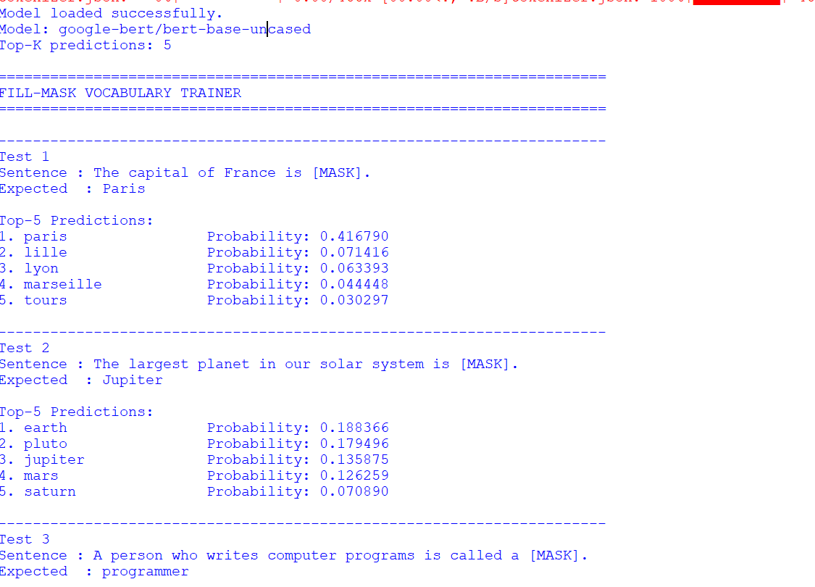
Output
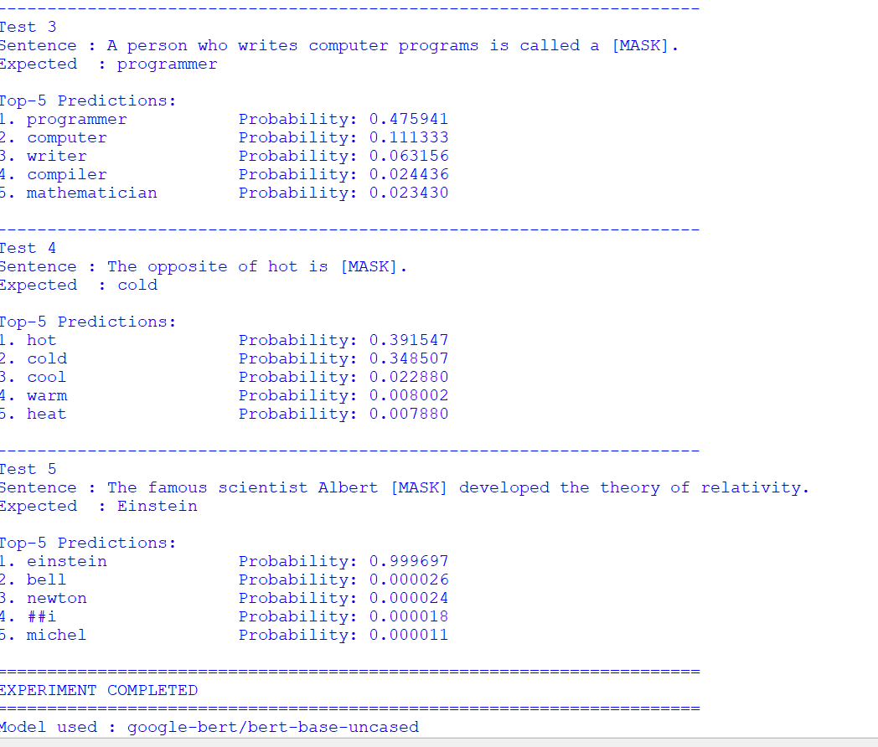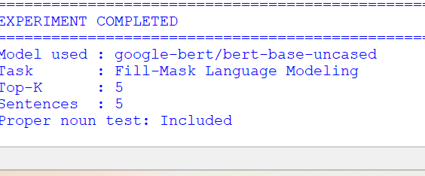

Observation
The model generates five possible predictions for each masked word along with probability scores. The actual predictions should be compared with the expected words.
Test | Expected | Top Prediction | Observation
1 | Paris | Fill after execution | Fill after execution
2 | Jupiter | Fill after execution | Fill after execution
3 | programmer | Fill after execution | Fill after execution
4 | cold | Fill after execution | Fill after execution
5 | Einstein | Fill after execution | Fill after execution
Error Handling
The program checks for empty input and the presence of the [MASK] token. It also handles model-loading and prediction errors.
Model and Parameter Justification
The google-bert/bert-base-uncased model is a masked-language model suitable for predicting missing tokens from surrounding context. Top-K is set to 5 because the assessment requires five predictions.
Result
The Fill-Mask Vocabulary Trainer was developed using a Hugging Face fill-mask model. It generates the top-5 predictions for five masked sentences and includes a proper-noun edge case.
Conclusion
The experiment demonstrates how a pretrained masked-language model can predict missing words from sentence context and can be used for vocabulary learning and cloze exercises.

